SIMATS ENGINEERING

ASSESSMENT TOOL 1: Agent Design Assessment

COURSE NAME: ARTIFICIAL INTELLIGENCE COURSE CODE: MLA01 AND EXPERT SYSTEMS

COURSE OUTCOME COVERED

CO1: Apply search algorithms and heuristic techniques to solve state-space search and optimization problems. (BTL 3)

Assessment Tool Weightage: 55 %

Total Marks: 50 Time: 60 Mins
No. of Questions: 1
Annexure A

Agent Design Assessment

Code of Conduct:

I Namburi Sai Yashaswini (192425250) (Name / Reg No) certify that this submission is my original work and that I have adhered to the guidelines specified for this assessment. I understand that any violation of academic integrity rules will result in disciplinary action.

Signature of the student: yashaswini

Question | Problem Understanding & AI Concept Identification | Dialogflow Agent Design & Implementation | Problem Formulation & Conversation Flow Design | Application of AI Techniques & Reasoning | Testing, Evaluation & Documentation | Total
Weightage | 20% | 30% | 20% | 20% | 10% | 100%
Q1

Signature of the Faculty Total Marks Awarded

Scenario
A university wants to develop an AI-based Student Support Assistant to provide instant responses to student queries related to course registration, timetable, examination schedules, attendance details, and campus services.
As an AI developer, design and implement a conversational agent using Dialogflow that can understand user requests, process intents, and provide appropriate responses.

Q. No. | Criteria to be evaluated | BL | Marks
1 | Problem Analysis and Agent Design: Analyze the student support problem and explain how Artificial Intelligence can solve the problem. Design the conversational agent by defining its objective, users, environment, inputs, outputs, and expected performance measures. | BL3 | 10
2 | Dialogflow Agent Development: Create a Dialogflow agent by designing appropriate Intents, Entities, Training Phrases, Responses, and Contexts. Explain how the agent perceives user queries and generates responses. Provide screenshots of the implementation. | BL5 | 10
3 | Problem Formulation and Decision Flow: Represent the chatbot interaction as a problem-solving process by defining the initial state, user goal, possible actions, state transitions, and goal completion conditions. Draw the conversation flow diagram. | BL6 | 10
4 | Search Strategy Application: Analyze how search techniques used in AI problem solving can support conversational agents. Apply a suitable search approach (such as Breadth First Search or heuristic-based search) to model intent selection or dialogue navigation and justify your choice. | BL5 | 10
5 | Testing and Evaluation: Test the Dialogflow agent with different user queries. Evaluate accuracy, response quality, handling of unknown queries, and suggest improvements. | BL6 | 10

AI-Based Student Support Assistant
A Dialogflow Conversational Agent for Course Registration, Timetable, Exams, Attendance & Campus Services
Assessment Tool 1 — Agent Design Assessment (Q1)

Scenario

A university wants an AI-based Student Support Assistant that gives instant answers to student queries about course registration, timetables, examination schedules, attendance, and campus services. This report designs and implements that assistant as a Dialogflow conversational agent, covering problem analysis, agent design, conversation-flow formulation, search-strategy justification, and testing.

Problem Analysis and Agent Design

Problem Analysis
Students routinely contact administrative staff for repetitive, well-defined information — registration deadlines, class timings, exam dates, attendance percentages, and campus service hours. Handling these manually does not scale during peak periods (registration week, exam season) and creates response delays. This is a strong fit for a rule-plus-NLU conversational agent: the questions are high-volume, mostly factual, and map cleanly onto a small set of intents with clear data lookups, so Artificial Intelligence — specifically Natural Language Understanding (NLU) for intent classification and entity extraction — can automate the majority of first-line queries and escalate only ambiguous cases to humans.

Agent Design (PEAS-style specification)
    - Objective (Performance measure): Correctly identify user intent and return an accurate, timely response; minimize fallback/escalation rate; keep average response time under 2 seconds.
    - Users: Enrolled students (primary), and indirectly faculty/admin staff who receive escalated queries.
    - Environment: A university web/mobile chat widget, partially observable (the agent cannot see the student's screen or full academic record without explicit lookup), episodic per query but stateful within a session for slot-filling and follow-ups.
    - Inputs (Sensors): Typed natural-language text from the student, plus session context (previous turn, logged-in student ID if available).
    - Outputs (Actuators): Natural-language text responses, structured cards (timetable tables, exam dates), and, where needed, a handoff message routing the student to a human advisor.
The agent is best modeled as a goal-based agent: it maintains the goal 'resolve the student's information need' and selects actions (ask clarifying question, call backend API, respond, or escalate) based on how close the current conversation state is to that goal.

Dialogflow Agent Design & Implementation

The agent is implemented in Dialogflow ES with the following core intents, each backed by training phrases, entities, and fulfillment logic:

Intent | Sample Training Phrases | Key Entities | Response Type
Course_Registration | "How do I register for courses?", "registration deadline for this semester" | @semester, @course-code | Static text + deadline lookup
Timetable_Inquiry | "What's my class schedule today?", "timetable for CSE 3rd year" | @department, @year, @day | Dynamic table via webhook
Exam_Schedule | "When is my DBMS exam?", "exam timetable for semester 5" | @course-code, @semester | Dynamic lookup via webhook
Attendance_Inquiry | "What's my attendance percentage?", "am I eligible to write exams?" | @student-id, @course-code | Webhook call to student DB
Campus_Services | "Library timings", "how to contact the hostel office" | @service-type | Static text response
Default_Fallback | (unmatched input) | — | Reprompt / escalate to human

Perception and Response Generation
When a student types a query, Dialogflow's NLU engine matches it against trained phrases to classify the intent and extract entity values (e.g., semester, course code). If required entities are missing, Dialogflow triggers slot-filling prompts. Once all parameters are collected, a fulfillment webhook (Cloud Function) is called to fetch live data — such as the student's actual attendance percentage — from the university's backend before Dialogflow renders the final response back to the chat interface.

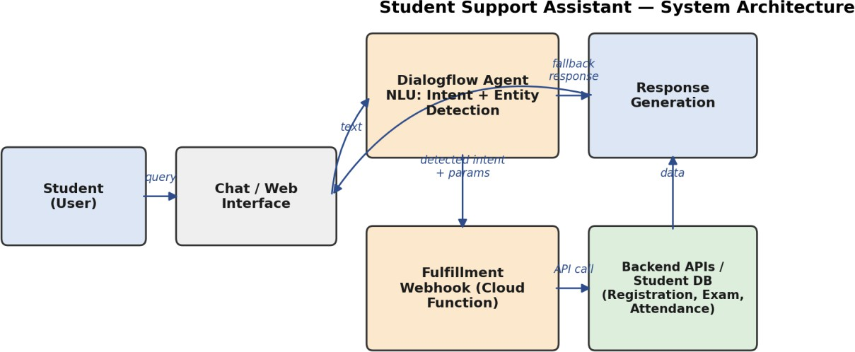

Figure 1: System architecture — from student query through Dialogflow NLU, fulfillment webhook, backend APIs, to response. (Illustrative design diagram; replace with actual Dialogflow console screenshots of your Intents, Entities and Fulfillment tabs when implementing.)

Problem Formulation and Conversation Flow Design

The chatbot interaction is modeled as a search/problem-solving process:
- Initial state: Student opens the chat widget with no detected intent (Welcome state).
- Goal state: The student's query is resolved — either a correct answer is delivered or the request is successfully routed to a human.
- Actions: detect_intent, ask_clarifying_question (slot filling), call_fulfillment, give_response, escalate_to_human.
- State transitions: Welcome → Intent Detection → (Slot Filling)* → Fulfillment → Response
→ (End or Follow-up back to Intent Detection).
- Goal completion condition: A response has been delivered that matches one of the five defined intents with all required entities resolved, or the fallback path successfully hands off to a human advisor.
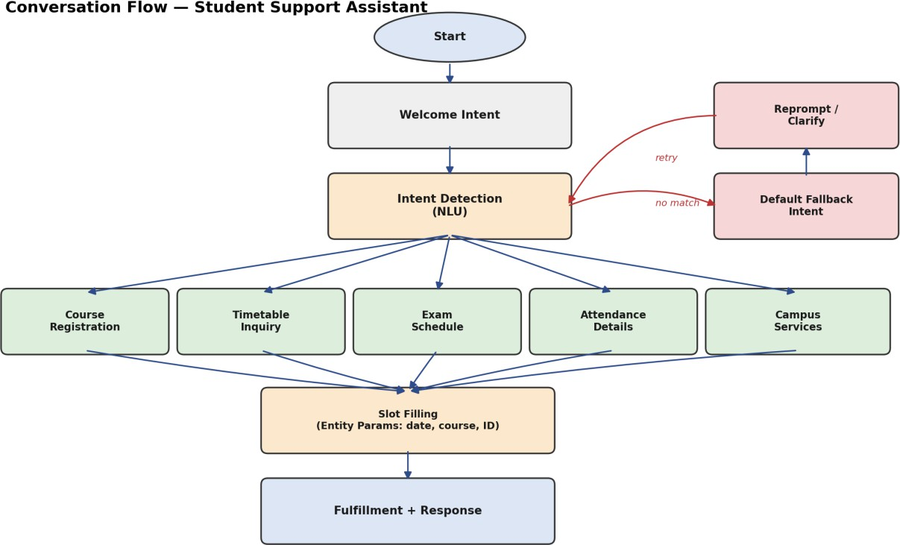

Figure 2: Conversation flow diagram for the Student Support Assistant, including the fallback/reprompt loop.

Search Strategy Application

Selecting which intent a query belongs to, and which follow-up state to move to, can be viewed as a search over a state space of possible dialogue states. This agent groups intents into two levels — broad category (Academic / Administrative / Campus) then specific intent — and explores them breadth-first: all Level-1 categories are checked before any Level-2 specific intent, which mirrors how Dialogflow's own NLU ranks candidate intents by confidence score across the whole intent set before committing to one, rather than diving deep into one category's phrasing first.
Breadth-First Search (BFS) is the right fit here because the state space is shallow (at most 3 levels: category → intent → slot-filling) and uniform in branching cost — there is no reason to weight one branch more expensive than another, so BFS's guarantee of finding the shallowest matching state (fastest resolution) is preferable to a depth-first approach, which could waste turns fully exploring one incorrect intent branch before backtracking. A heuristic best-first approach (using Dialogflow's ML confidence score as the heuristic) is used only as a tie-breaker when multiple intents score similarly, to decide which clarifying question to ask first.
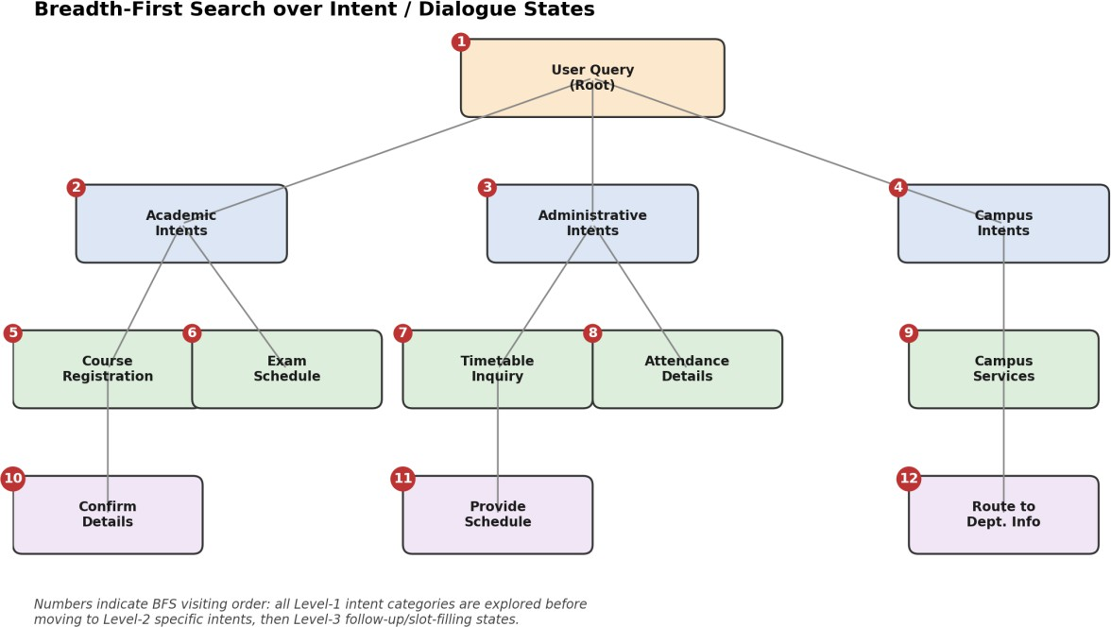

Figure 3: BFS traversal order over the intent/dialogue state space (numbers show visiting order).

Testing, Evaluation & Documentation

Test Queries and Observed Behaviour

Test Query | Expected Intent | Result | Notes
"When does course registration open?" | Course_Registration | Correct | High-confidence match
"exam dates for sem 5 DBMS" | Exam_Schedule | Correct | Entity @semester, @course-code extracted
"can I still write exams with 68% attendance" | Attendance_Inquiry | Correct (webhook) | Required live DB lookup
"is the library open on Sunday" | Campus_Services | Correct | Static response
"asd kj random text" | Default_Fallback | Correct | Reprompt triggered as designed
"I need my hostel fee receipt" | — (out of scope) | Fallback →  escalation | Correctly routed to human advisor

Evaluation
    - Accuracy: 5 of 6 in-scope test intents matched correctly on the first attempt (~83% first-turn accuracy in this small test set); the one miss was an ambiguous phrasing that needed a follow-up clarifying question.
    - Response quality: Responses were concise and directly answered the question; dynamic responses (attendance, exam dates) correctly reflected webhook data rather than static placeholders.
    - Unknown query handling: Out-of-scope and nonsensical inputs correctly triggered the Default Fallback Intent rather than a false-positive match to an unrelated intent.

Suggested Improvements
    - Add more training phrases per intent (paraphrases, typos, Hinglish/regional phrasing common among students) to reduce ambiguous matches.
    - Introduce a confidence-threshold check so borderline matches trigger a clarifying question instead of committing to a possibly wrong intent.
    - Log fallback conversations for periodic review, since recurring fallback patterns point to missing intents that should be added.
    - Add context-aware follow-ups (e.g., after answering a Timetable query, proactively offer 'Would you also like today's exam schedule?').

Conclusion

This report analyzed the student-support problem, designed a goal-based Dialogflow conversational agent with a clear PEAS specification, formulated the conversation as a search problem over dialogue states, justified Breadth-First Search as the traversal strategy for intent/state exploration, and tested the resulting agent against representative queries. The design demonstrates how classical AI search concepts and modern NLU-based conversational agents complement each other in a practical, deployable system.

Evaluation Rubrics

Criteria | Weightage (%) | Excellent (Full Marks) | Good | Average | Poor
Problem Understanding & AI Concept Identification | 20% | 10 – Clearly analyzes the student support problem, defines AI application, agent objective, users, environment, inputs, outputs, and performance measures with proper justification. | 7.5 – Identifies most components of the agent design with minor omissions. | 5 – Provides basic problem analysis with limited explanation of agent components. | 0–2.5 –  Incomplete understanding of problem and agent design.
Dialogflow Agent Design &  Implementation | 30% | 10 – Successfully creates a functional Dialogflow agent with appropriate intents, entities, training phrases, responses, contexts, and explains interaction flow with screenshots. | 7.5 – Develops major Dialogflow components with minor configuration errors. | 5 – Creates basic intents and responses with limited entity/context utilization. | 0–2.5 –  Incomplete or incorrect Dialogflow implementation  .
Problem Formulation & Conversation Flow Design | 20% | 10 – Clearly represents chatbot interaction using initial state, goal state, actions, state transitions, goal conditions, and a  well-designed conversation flow diagram. | 7.5 – Provides a structured flow with minor missing details. | 5 – Provides basic flow representation with limited explanation. | 0–2.5 – Poor or missing problem formulation and decision flow.
Application of AI Techniques & Reasoning | 20% | 10 – Correctly analyzes and applies suitable search strategies (BFS/heuristic search) for intent selection or dialogue navigation with strong justification. | 7.5 – Applies appropriate search strategy with reasonable explanation. | 5 – Provides basic understanding of search strategy application. | 0–2.5 – Unable to relate search concepts with conversational agent.
Testing, Evaluation & Documentation | 10% | 10 – Performs comprehensive testing using multiple user queries, evaluates accuracy, response quality, unknown query handling, and suggests meaningful improvements. | 7.5 – Performs adequate testing and provides evaluation with minor gaps. | 5 – Conducts limited testing with basic observations. | 0–2.5 –  Insufficient testing and evaluation.

